Uses Window Forms.

Fill in the Task, Due Date and Status boxes and click Create to create a new task.

Tasks are stored using Entity Framework and stored in a local Windows SQL server.

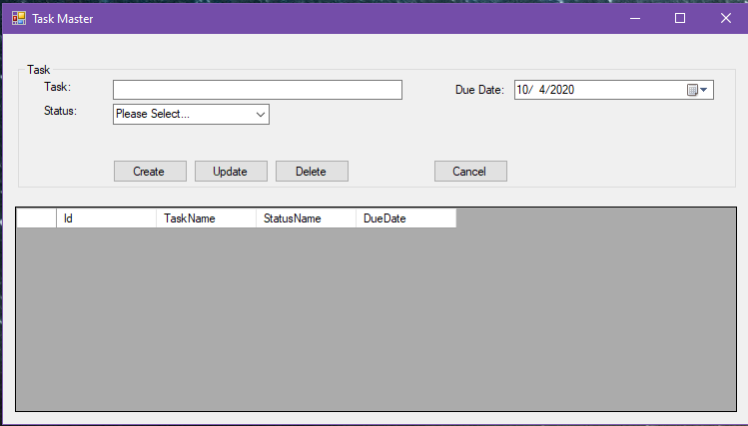

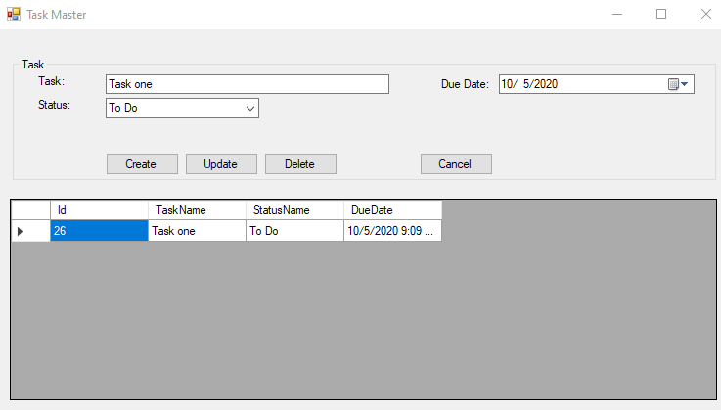

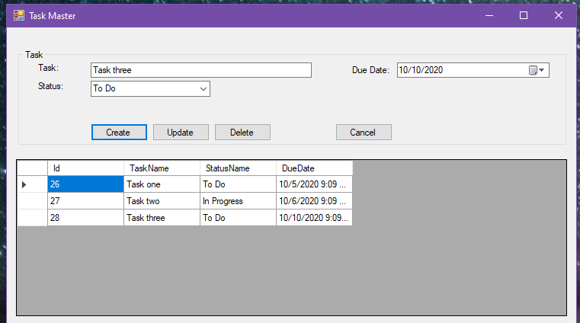

Tasks can be updated and deleted. Changes will persist in the database and refreshed within the windows form.